BATTERY CONTROLLOR RE-Program procedure

1. At SCADA interface, clicke “RE_PROGRAM” tag

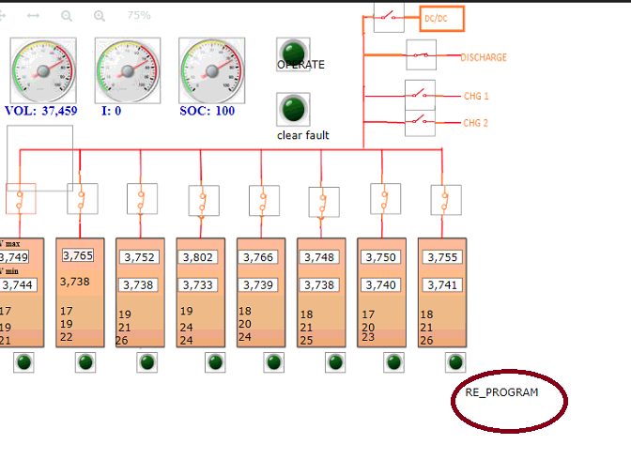

1. Input passward “12345” and click “YES”

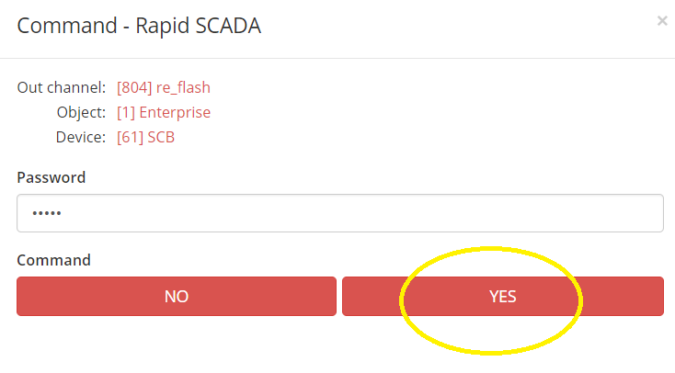

1. Ping “10.10.10.252” make sure bootloader running

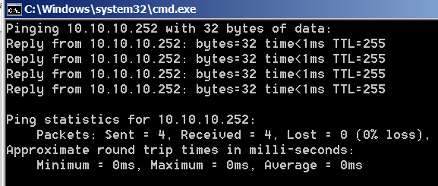

1. Run program “tftpd32” and input below information at “tftp client” tab

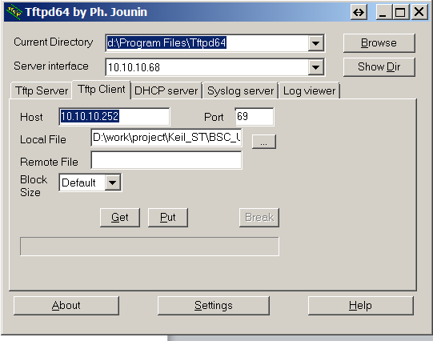

1. Select local File and click “Put” button

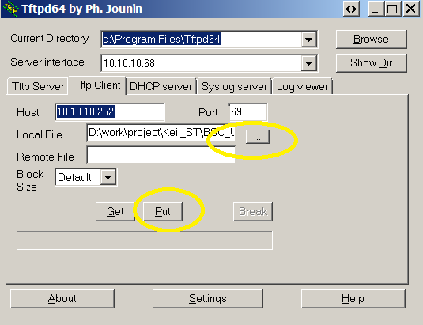

1. Wait until below success window popup

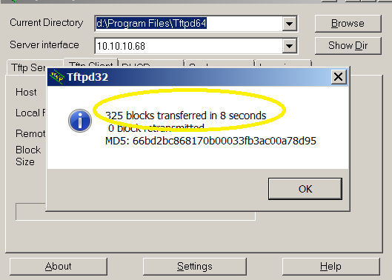

Note: 1) if popup window shows “transferred in 0 seconds” means reprogram failed. You may need redo from step 1

2) before this step, power on/off operation is perfered.

1. Ping “10.10.10.253” to confirm main program is running.

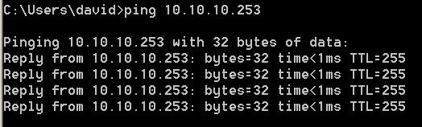

1. Back to SCADA interface to confirm all information displayed. Restart scada communication

